Creating a Spring Boot based Web Service using STS

Web Service – REST (Representational State Transfer) [JSON/XML]

SOAP – Simple Object Access Protocol

Step 1: Open STS

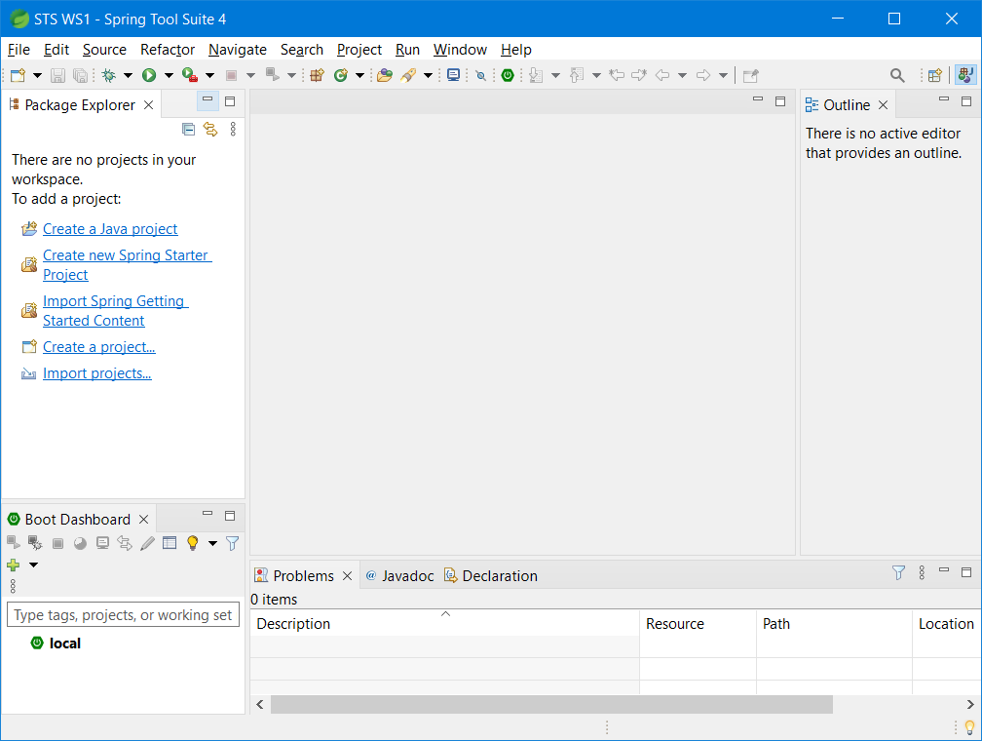

Step 2: File -> New -> Spring Starter Project

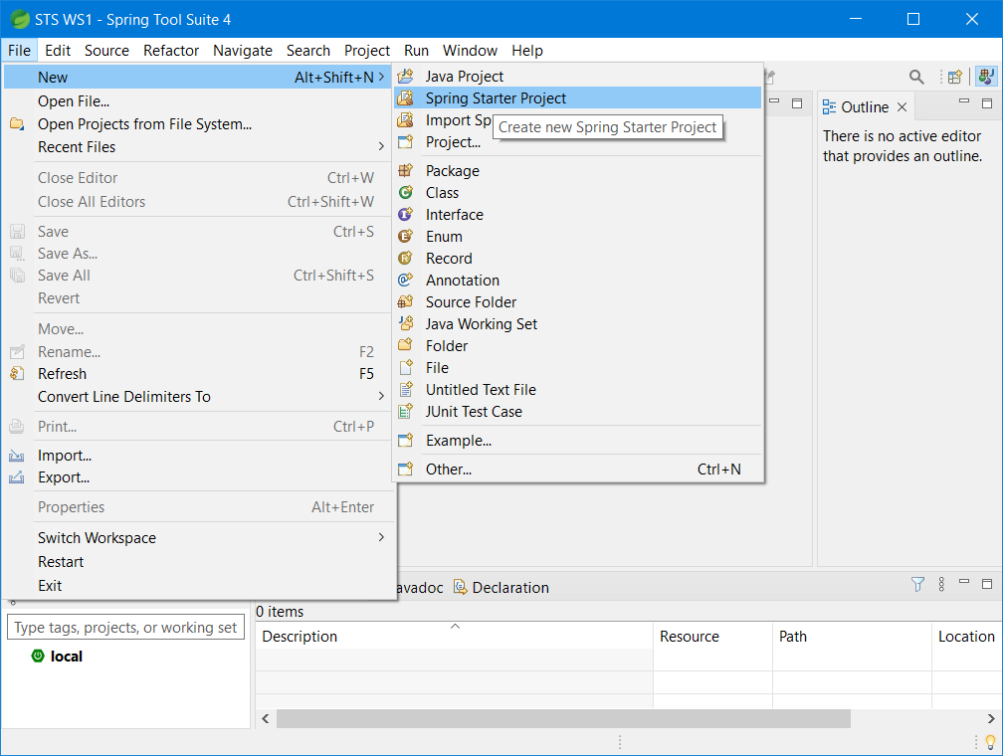

Step 3: Filling all the necessary inputs like shown below and click “Next” button

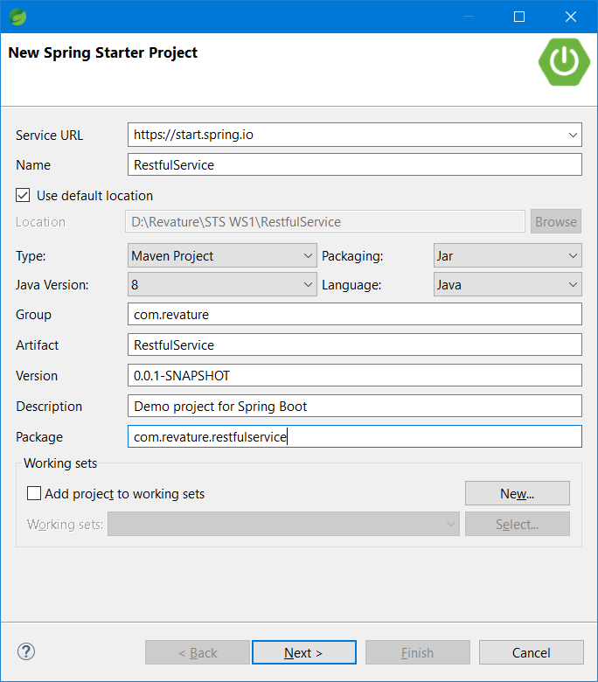

Step 4: select spring boot version & required dependencies to the project and click “Finish”

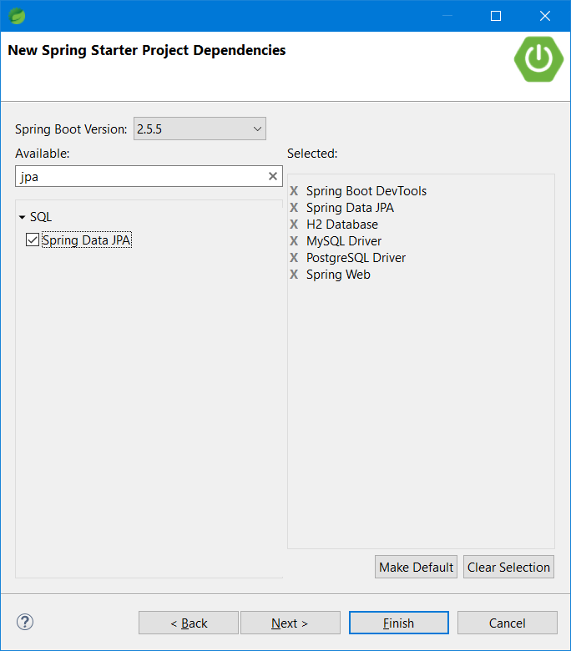

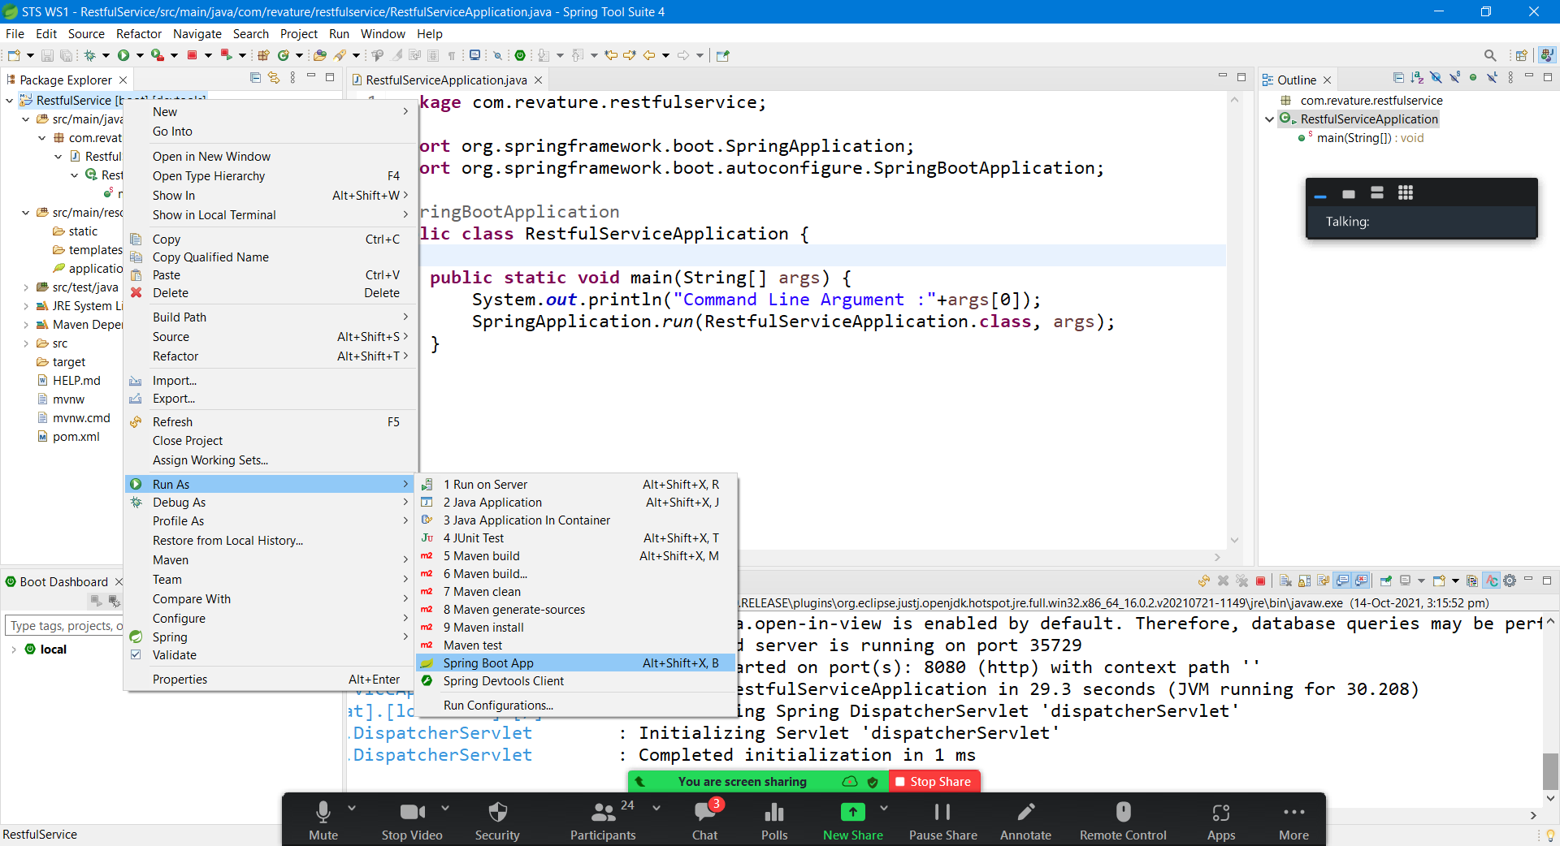

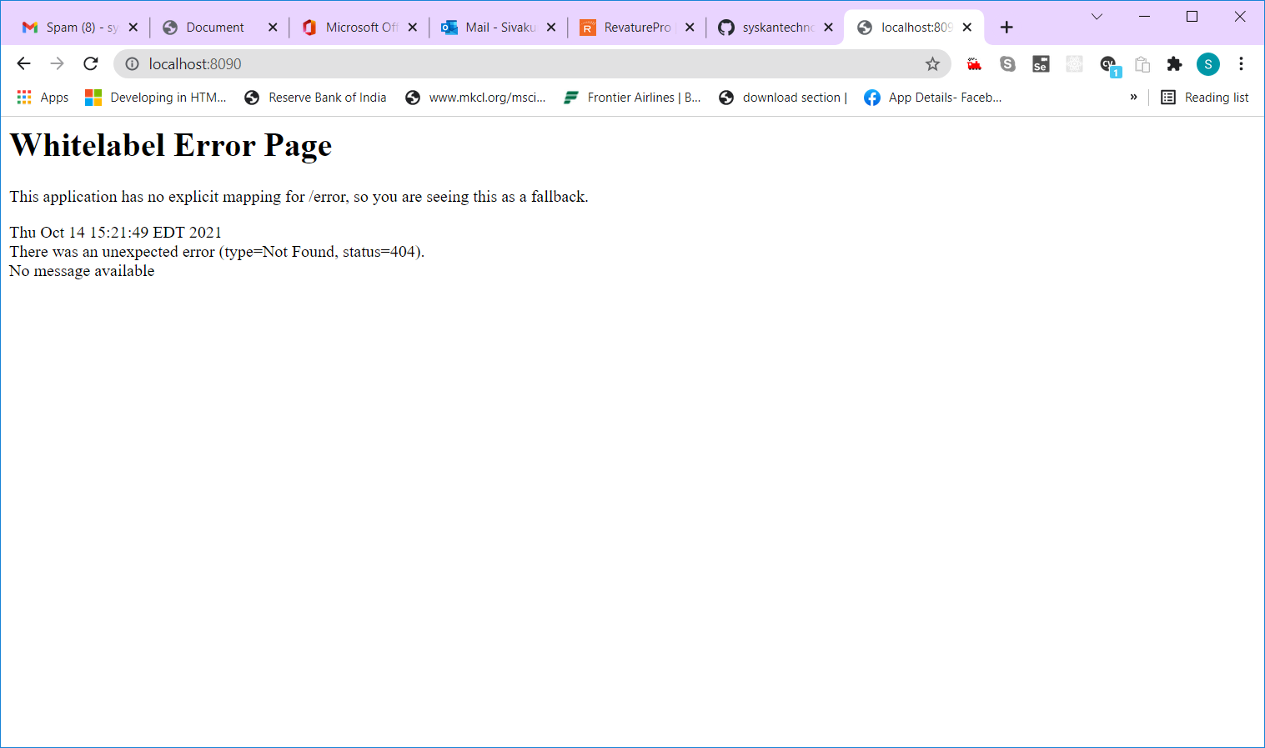

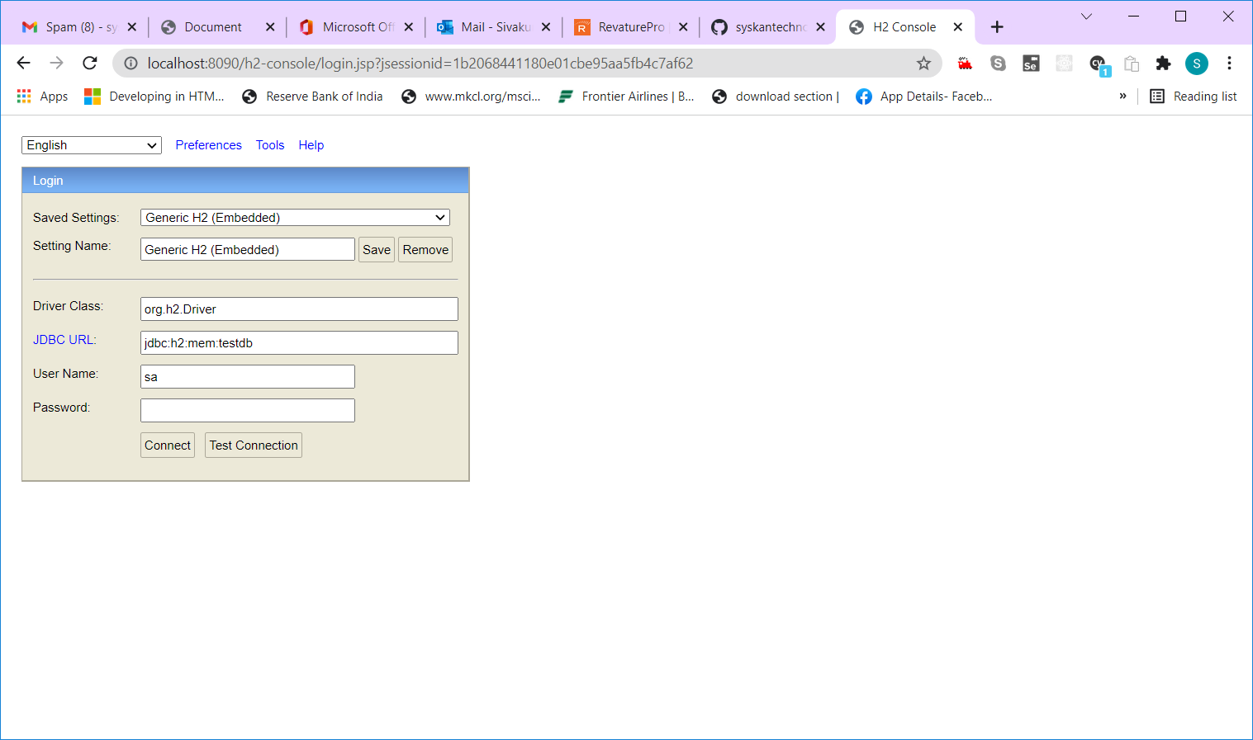

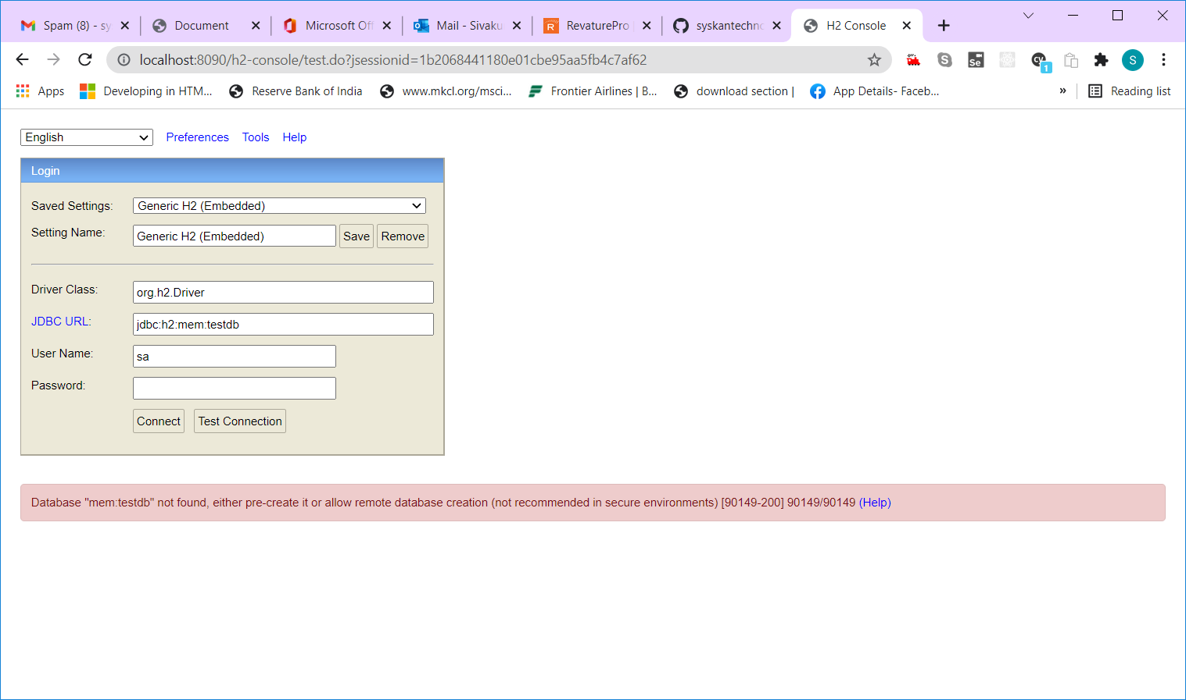

jdbc:h2:mem:a58ab49a-3ff1-482f-80fb-f3694d54fcbb

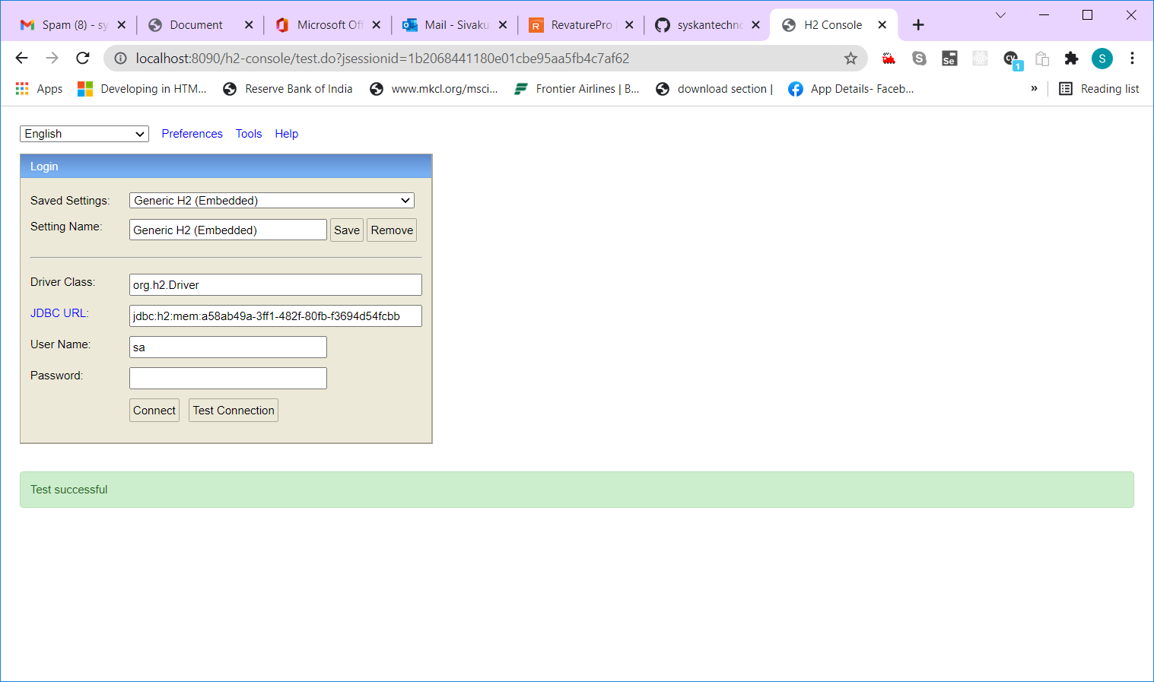

Packaging structure

Com.revature.restfulservice

Com.revature.restfulservice.controller

Com.revature.restfulservice.model/entity

Com.revature.restfulservice.repository

Com.revature.restfulservice.service

Com.revature.restfulservice.exceptions

Com.revature.restfulservice.util

Com.revature.restfulservice.config